**Tableau Dashboards – the core of Tableau**

I’ll give you a very simple way to understand the components of Tableau. Tableau essentially has three parts to it — the**worksheet**, the **dashboard** and the **layout containers**. Tableau dashboard is the consolidated display of all worksheets. Each worksheet contains visualizations flowing from different data sources or different kinds of data itself. Layout containers allow you to change the relationships between dashboard components (such as graphs or charts). These components can be arranged horizontally or vertically. The most important part here is the Tableau dashboard, where the actual magic happens, but it can be understood when you have created more than one worksheet. In the following part of the blog, I will try to illustrate how to build a worksheet and a corresponding dashboard. More importantly, it is intended to help you understand how to use different kinds to visualizations to unlock different insights.

**Understanding Tableau dashboards through a use-case**

The working of Tableau is best understood through an example where there are different data types, each of which has the potential to reveal valuable business insights. An ideal use-case can be that of a retail superstore where you need to unlock insights from data around regional sales, individual store transactions, product categories consumer segments, sales figures, discount margins, profit and many others. The business needs to understand which region is more lucrative than others, which customer segment to focus on, and which segments to reduce investments in. Each of these insights require data to be processed in a different way, with the ultimate aim being that of business productivity & profitability. Let’s now understand the exact nature of insights we can get from different types of data for our superstore:

1. Overall sales and performance of the superstore: The first logical step is to get an idea of performance of the superstore over time. For this, we need data around sales from different regions on a quarterly basis. We also need to understand which region is more profitable or loss-making compared to other regions.
2. Performance of different states: Having got region-wise insights on profits and losses, we can create a matrix of sales vs profits at a state level – 4 quadrant matrix with sales and profit as X and Y axis respectively, with the mid-point being the central tendency. These states in the 4 quadrants can be mapped to understand different scenarios. For instance, business can take a decision to invest more in a state that has lesser sales but higher profits. Another state may end up raising a red flag if sales are higher but profits are declining.
3. Performance by different customer segments: It is also essential for the business to know which customer segment is driving sales and profits in different regions. For example, a pie chart with a view of customer segments and sales/profits can help the business formulate future strategies – which segment should be the primary focus area, for example B2B consumer segment might be driving the maximum profit with very less sales number – clearly, there is a huge opportunity to expand the B2B segment in this particular region.
4. Revenue generation by category: Within specific regions and customer segments, we can get data around specific product categories and how they compare (in terms of sales and profits) with one another. If kitchen appliances are yielding better profits than cleaning equipment, it is a valuable insight that can influence future plans.
5. Forecasting sales: The past sales and profit trend over the quarters will help in forecasting the values for the coming quarters in the next year. Business can also map their actual values to the forecasted values to measure the impact from the insight action points. Let’s now look at each of these scenarios in detail. I’m using the Tableau Public version. The first step is to open a new worksheet and connect to the dataset. Assuming our superstore data is in Excel, we choose the same. Tableau automatically detects the various data types in the Excel and classifies them into String data type, Date data type, Boolean data type, among others.

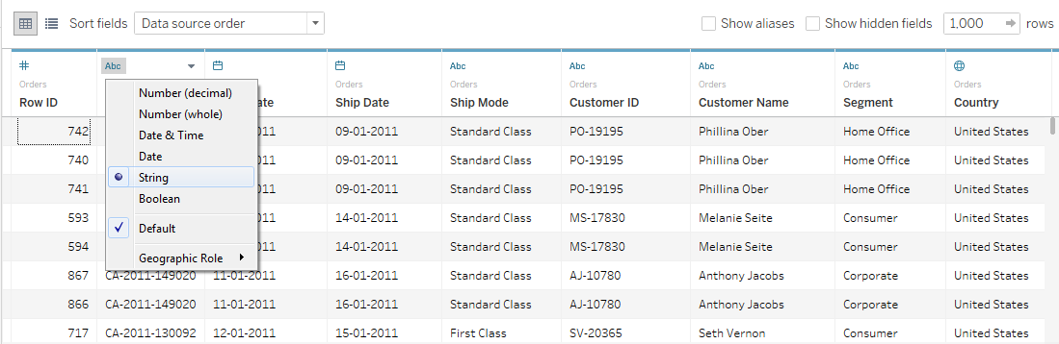

At this stage, it is important to understand two concepts — Dimensions and Measures. According to Tableau, a measure is a field that is a dependent variable, that is, its value is a function of one or more variables. In simpler words, Tableau classifies any field containing numeric value (quantitative) as a measure. Qualitative, categorical information is automatically treated as a dimension. Let’s understand this with a simple example. Suppose your annual sales was $100 million, specific sales mapped to customers, region or store is the dimension while $100 million is the measure.

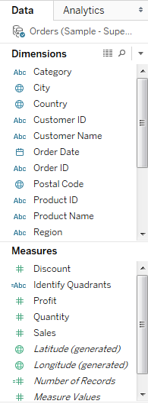

The next step is to understand the various types of visualizations in Tableau. Bar charts, box plots, Pareto charts…. Apparently, many more types of charts exist in the world, and the best possible news I can give you at this moment is the fact that Tableau does not require you to know anything about them. One, Tableau is intelligent enough to suggest which kind of visualization will suit your data type and two, allows you to manually change it if you wish to. For our superstore use-case, if we were to sift the data for profit leaders, that is to have a view of which regions were bringing in most profits, all you need to do is to choose the colour, size and label, and drag-drop them into the worksheet. You can co-relate colour to size to see the bigger profit center in a bigger size. Tableau simply requires you to assign latitude and longitude values, and it will churn out the visualizations in real-time.

**Overall sales and profits**

As we can see in the screenshot below, Tableau generates a symbol map of ‘profit leaders’, essentially a visualization of specific states and their profits.

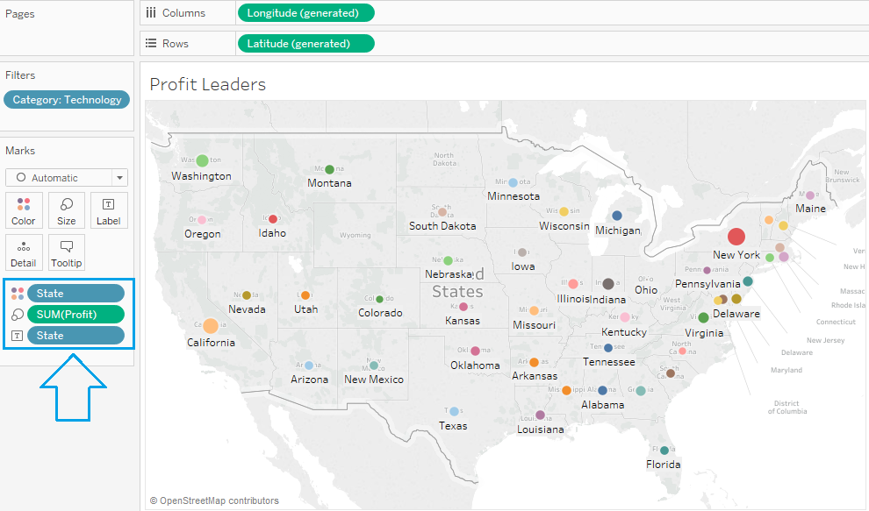

Overall sales and performance can be displayed as a line graph that gives an idea of region-wise performance, in terms of both sales and profit. We can derive insights from this visualization such as Q4’ 13 had a surge in both sales and profit compared to other quarters. Although, Q2’14 had a marginal increase in sales, but the business saw a drop in profit compared to last quarter.

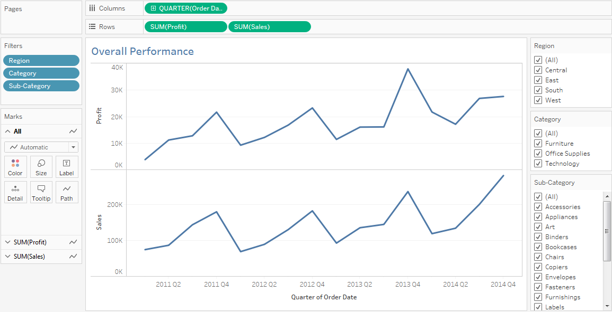

**Performance of different states**

In the following visualization, we have created a 4 quadrant matrix with X-axis as sales and Y-axis as profit, mid-point being the central tendency (median in this case) of both sales and profit axis.

This visualization can help us divide the states in major 3 business strategic focus areas – Retain, Develop and Divest. States on the top right corner with high sales and profit are currently at a good position and business would want to retain this in the coming future. States above the sales axis and close to the profit axis can be looked upon as opportunity by the business wherein increase in sales would help increasing the business profits – Develop strategy. States with low sales and low/negative profits or higher sales but negative profits are definitely not the areas where the business should focus on divesting the money. This helps heavily in formulating business investment strategy.

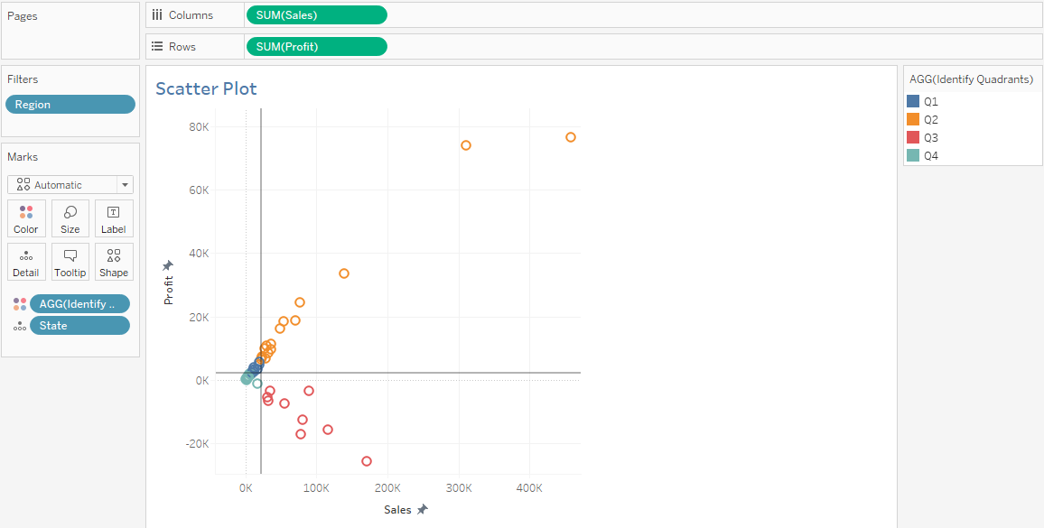

**Performance of different customer segments**

With a visibility at a region and state level, we can now look at which consumer segment is driving the sales and profits and identify the focus areas in the customer segment (among Customer, Corporate and Home Office).

For example, we can see that in Central region, although the consumer segment is contributing to 50% of sales, profits have a lower share for this segment. However, the Corporate segment has a much higher profit share with lower sales contribution. Definitely, the business should focus on increasing the Corporate sales contribution which can impact the profitability for the business.

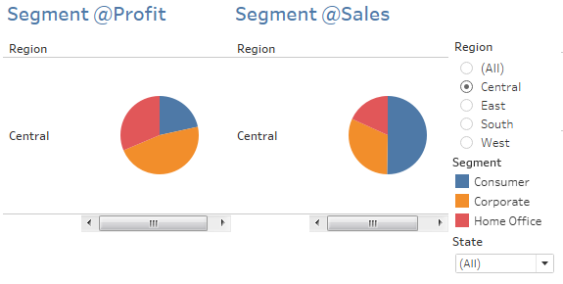

**Revenue generation by category**

The next logical step is to derive insights at a product category level. We can understand that which product has higher sales and profits in a particular region and consumer segment. Or how the various product categories have performed in terms of sales and profits.

In Tableau, you can add multiple filters to your data to get the exact insight you desire. For our superstore, say we need insights on category-wise revenue, we need to simply add filters for Region, Category, even a Sub-category. Then assign what you need to display on rows and columns. As you can see in the sheet below, the sum of sales is represented as columns, and categories are represented as rows. The data is filtered for Region, State and Segment, and appears colour-coded orange to represent low profits and blue to represent higher profits.

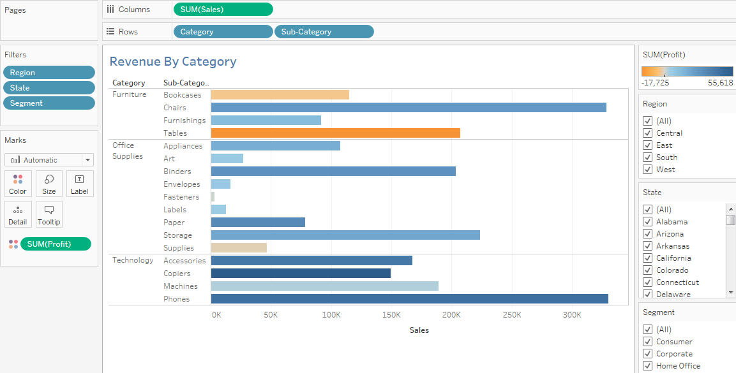

In order to help you understand the simple steps involved in choosing the right filters and creating your own visualization with the super store data set, here’s a quick step-by-step visual guide:

**Step-by-Step Visual Guide to create Tableau Dashboard:**



By now, we have covered the basics of data visualization with Tableau. Rest of the magic are sub-sets of these concepts. The next logical step is to forecast sales and profit based on the historical quarterly performance trend. The business can later compare the actual sales and profit numbers with the forecasted value to perform gap analysis and measure the impact from the actions taken during the quarter.

